Big Bang Theory in Hydrodynamics
Sheldon Cooper¹ and Howard Wolowitz²
¹ Department of Theoretical Physics, BTU, 03044, Cottbus, Germany cooper@b-tu.de
² Department of Theoretical Physics, BTU, 03044, Cottbus, Germany, wolowitz@b-tu.de

I. GENERAL GUIDELINES

This template for the 1st Workshop (IRN-Hydrobio, CNRS) shall be used in the preparation work of the abstract when using MS Word. The maximum length of the abstract is 2 pages in size A4. It is not required to use section headings.
The format and typesetting rules for the abstract are as follows.
1. Paper size is A4, text width 160 mm, text height 247 mm.
2. Font to be used is 'Times'. The text must be left and right justified. The following font sizes must be used:
- title 13pt,
- author names 11pt,
- affiliation 10pt,
- body of the text 11pt,
- figure and table captions 10 pt.
3. No page numbering.
4. The title should must be in bold and the presenting author should be underlined.
5. The affiliation is indicated by footnotes using the number format "¹, ²…" and Italics.

II. FLOATS

Make sure that the labels and all other text in the figure/figures have readable and comfortable font size, i.e. not smaller than 9 pt. The use of color figures as in fig. 1 is encouraged.

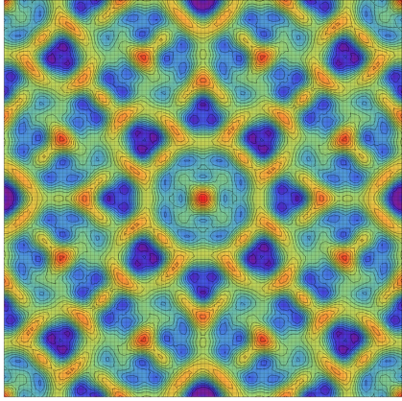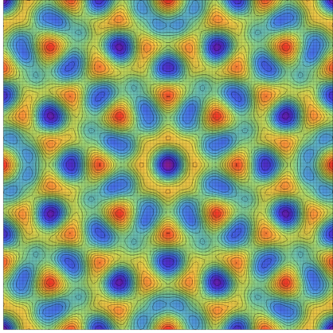

FIG. 1. An example of caption. Left: A figure on the left; Right: A figure on the right.

III. REFERENCES

References should be created using the footnotes option. See the examples below [1 , 2 ] for the citation style.

[1] U. R. Nothing, I. M. Nobody and B.U. R. Friend, How to write a paper that receives as many as possible citations, J. Improbable Res. 123, 456 – 478 (2006).
[2] S. Hawking, A brief history of time: from Big Bang to black holes, Transworld Publishers, London (2011).

